The purpose of this app is to create an automated facility to allocate teachers on a roster in the case of absentees. The main roster is exported in PDF from an existing app and will be imported once per year and will not ever change for the full duration of that year. The only aspect that may change, and this is the purpose why this app is designed is the names allocated to these rosters, in which case the instruction or the addition will be clear as explained below. Below is an example of such a roster. Rosters consists of 6 day cycles that never change through the year that keeps repeating after every six days as the cycle is completed. There are currently 77 rosters, 1 for each teacher. Eact teacher roster is displayed on a 8X6 matrix. The horizontal plane represents the days (dag in Afrikaans, i.e. dag 1 , day g etc.) The vertical plane represents the period of the day, i.e. PER 1, PER 2 etc. Blank spaces are to be ignored for the purposes of this app, because these represent open or empty periods. Note: the subjects, room (kamer and # i.e., 64 below) Key # and the grade never changes or is never altered I always stays in the period block allocation. The name of the teacher, Name and initials appear in the tope left block. In uppercase. In all rosters there are names in a blue/grey block like in the below block “RU (Room Used C Lidick (initial and name) these are to be treated as empty periods/blank spaces.
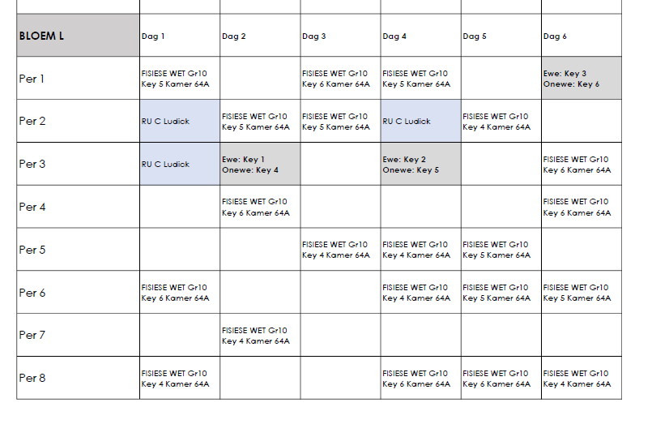

Teacher Database (Preloaded)
There will be a teacher DB that contains the names of all teachers. This is a very simple DB containing teacher Surname and initials what classroom they are allocated to and whether it’s a fixed or floating allocation. This means quite simple that some teachers have fixed allocated classroom while other do not have this facility so they utilise other teacher’s rooms when this room is not busy/used/allocated and there are empty periods available for floating teachers to be used.
List of absenteeism’s
Daily there are absenteeism. The list of absenteeism’s will be selected form a drop-down menu. The drop down has a type in facility to enable name filtering, and the names has a radio button before the name to enable selection.
List of available teachers.
This list is also preloaded for the year and is linked to the roster cycles, i.e. cylcel 1 will always have the same people who are not allocated for that cycle day and so will cycle 3 , 3 etc.
The actual operation.
Every day there are a number of people that are absent, who should have filled the positions on the permanent rosters. It so happens that each day there are absenteeism’s. These absenteeism’s will be provided by the user each day, selected from the drop down menu mentioned above,. The app sould be able to detect from the rosters the periods that are affected by this absenteeism’s. The app should then from the list of available teachers allocate available teachers to the slots in the roster that are affected by the absenteeism’s.
Rules for allocating available teachers.
The app should keep a database indicating the number od time teachers has been used to fill roster absenteeism spots. And the app should distribute equally the number of times such a teacher is allocated. i.e. If there are teachers A, B, and C available on a day. The app the app should run a scan of the number of times teachers were allocated and if for example C was only allocated once and A and B allocated 5 and 4 times respectively, first assign Teacher C to “catch up” to A and B. The maximum number of times a teacher that has fallen behind may be used on a given day is twice. Irrespective of the number of times such a teacher has fallen behind. The only time this teacher can be selected again, will be the next day/cycle. In other words, the app should continuously seek to appoint available teachers the same number of occasions but may not allocate a teacher on a give day more than twice.
Note: an absent person is not an available teacher and should be ignored when allocating available teachers. Even if a name is on the list of available teachers, if that person is in the list of absentees, that person must be ignored for selection.
App layout
Sidebar with main window displaying the rosters.
In the left sidebar:
- List of absenteeism tab.
This has the following filter capacity, used as fiactirs to be considered in the actual calculation of who will be allocated where.
- The drop-down list previously explained (selecting the teacher that is absent)
- A drop down to select the day that is affected This goes along with a “day” drop down to select the day on which this app will be run, i.e., day 1, day 2 etc as per the rosters.
- A drop down to select the period from where the calculation should be performed see below description
- A radio click button that exposes 2 options. First option: “First version for the day” and second option “second version for the day”.
This will be used in the algorithms to identify the periods on that day across 77 rosters that are affected by the absenteeism. After the day and the absenteeism list is compiled, there is a submit button submitting will:
- Identify the day affected by the absenteeism
- Identify the periods, i.e. from period 1 or 2 or 3 etc. When the calculation is run, the periods before the selected periods are ignored and not included in the calculation and considered as already executed. i.e. if period 3 is selected periods 1 and 2 are not part of the calculation, only 3 onwards, for that specific day.
- Select a name for the available teachers, apply the rules specified under “Rules for allocating available teachers” and
- Physical write the name of the replacement teacher that will fill the role of the absent person inside the block that is affected right above the current content (current content not to be altered at all) in Bold red in the format Surname first then initial as per the list of available teachers.
- Please note. In most cases the calculation will be run for the entire day, in this case the radio button (first version for the day will be used and the entire calculation for the day is rune as explained, but sometimes as indicated a teacher may become absent halfway through the day. In such an instance the name of the absent teachers will be added to the absenteeism list and the radio button for the “second version of the day” will be clicked. This will be an indication that only one teacher roster will be affected and not the entire roster that was already calculated for the day. This time teachers already allocated to the roster may not be selected again, even if they appear on a period after the one selected for example period 5 onwards. Other drops down that will accompany this second version of the day will be the period from. Periods before will not be affected only periods after and also only the roster for the teacher that is affected. The other rosters to remain unaffected by this “second” calculation.

- Lists of available teachers. This is a preload facility used to upload an Excel spreadsheet. The excel spreadsheet will be uploaded in a specific format as per the example that is provided (attached). This Xcel spreadsheet will be replaced from time to time as and when needed.
- Main roster: Here the main roster is uploaded in PDF. This PDF is an excel export and should be used to populate the main roster in the main page. This PDF may be changed from time to time as the roster changes. This will go hand in hand with changes in the list of available teachers. The main roster page has a filter capacity. There are only 3 filters, filter by teacher name: Top left in roster. Filter by day, and filter by period. This filter can be used simultaneously to obtain optimal filter results.
Exception to the rule
Normally this exercise is performed once per day. It sometimes happens that this situation changes midday. In such a case. The roster has already been executed for example 45%, and a need arises as another absenteeism occurs, unforeseen, to readjust the roster. The exercise will be run
This app will be hosted entirely in a desktop environment. No online hosting require and it’s a personal tool that will be used by one person so no user access required.

